Comparative Analysis of Network Performance Across Wired, Wireless, and VPN Connections Using iperf3 and ping

Gowtham D. Prasad

Abstract—This paper investigates network performance characteristics within daily-use online environments by employing a combination of measurement tools across various network configurations. The primary objective is to evaluate the impact of different connection types and routing paths on critical network performance metrics including throughput, latency, and packet loss. Using iperf3 and ping, we conduct quantitative measurements of these metrics under three distinct network conditions: (1) wired campus connection, (2) wireless connection with VPN enabled, and (3) off-campus mobile hotspot. iperf3 is used to assess bandwidth and throughput efficiency, while ping captures round-trip latency and packet loss rates. The complementary use of these tools allows for cross-verification and comprehensive analysis. Our results highlight significant variations in performance depending on the connection type and geographic routing paths, offering insights into optimal configurations for improved end-user network experience.

Index Terms— Blockchain, Cryptocurrency trading, price prediction, trading strategies, machine learning

I. INTRODUCTION
In today's increasingly interconnected digital landscape, network performance has become a cornerstone of both personal and professional life. From video conferencing and remote collaboration to online gaming, cloud computing, and multimedia streaming, users rely heavily on consistent and high-quality internet connectivity. As applications continue to evolve in complexity and bandwidth demand, even minor network delays or inconsistencies can result in significant drops in usability and user satisfaction. Consequently, measuring, monitoring, and understanding the characteristics of various network environments is essential not only for improving user experience but also for diagnosing issues, designing robust infrastructures, and supporting the development of high-performance systems.
Network performance encompasses a wide array of metrics, including but not limited to latency, jitter, packet loss, throughput, and bandwidth utilization. These metrics can be influenced by several dynamic and static factors, such as the type of physical medium (wired vs. wireless), network topology, routing protocols, signal strength, congestion, and distance to the destination host. Additionally, the use of security services such as Virtual Private Networks (VPNs) or firewalls may add another layer of complexity, potentially altering traffic behavior or introducing overhead. In this context, practical and accurate measurement tools are crucial for capturing and interpreting the performance data across different types of network connections.
This paper presents a practical study aimed at evaluating network performance in real-world scenarios using open-source and command-line-based diagnostic tools. The core goal of the study is to examine how performance varies under different access conditions and to compare the metrics obtained through multiple tools that offer complementary insights. Specifically, we use iperf3 to measure TCP/UDP throughput and bandwidth, while ping is employed to evaluate round-trip time (RTT) and packet loss. These tools are widely used in academia and industry due to their accuracy, flexibility, and ease of use across multiple operating systems. Additionally, traceroute and ipconfig (or ifconfig on UNIX-based systems) are utilized to gather supplementary data on routing paths and network interface configurations.
To capture the variability in performance, the experiments were carried out under three different network conditions that simulate typical user environments:
- A high-speed wired Ethernet connection on a university campus network,
- A wireless Wi-Fi connection using a VPN, and
- A wireless Wi-Fi connection only.
These cases were chosen to reflect common contexts in which students, professionals, and mobile users operate. The first scenario represents a relatively stable, high-bandwidth, low-latency environment. The second introduces VPN overhead and wireless variability, simulating a remote work or study situation. The third focuses on mobile data connectivity, which is increasingly relevant due to the proliferation of remote and hybrid lifestyles. Each environment presents its own set of challenges and performance constraints, enabling a well-rounded analysis of how network metrics are affected by changes in physical and logical access.
The main contributions of this paper are threefold. First, it provides an empirical analysis of throughput, latency, and packet loss across diverse network conditions. Second, it demonstrates how using complementary diagnostic tools leads to a more comprehensive understanding of network behavior, especially when correlating data from multiple sources. Third, it offers practical insights and recommendations for users and administrators seeking to improve network efficiency or troubleshoot performance issues based on real, quantifiable data.
By combining iperf3 and ping, we ensure coverage of both high-level and low-level network performance aspects. For instance, while iperf3 excels at stress-testing available bandwidth and analyzing throughput in both client-server and reverse directions, ping provides a more lightweight method for continuously probing latency and observing time-sensitive loss patterns. These complementary strengths make the tools highly suitable for side-by-side deployment in diagnostic scenarios.

II. Tools and Methodology

A. Network Configurations
The performance measurements were conducted in three different network conditions, each designed to reflect real-world environments commonly encountered by students, professionals, and mobile users. These are outlined as follows:
- Wired Ethernet on Campus
In the first configuration, a laptop was connected to a university campus network via a high-speed Ethernet cable. This setup provided a low-latency and high-bandwidth connection with minimal external interference. It served as the control or baseline scenario, as wired Ethernet typically offers superior performance and reliability compared to wireless connections. The topology of such an environment is shown in Fig 1.
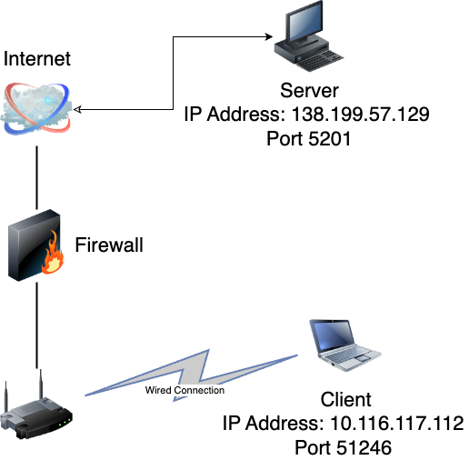
Fig. 1. Client-Server Topology Connected via Ethernet.

- Wi-Fi with VPN
In the second scenario, a laptop was connected wirelessly to UA-Guest Wi-Fi network with an active Cisco Virtual Private Network (VPN) session. This setup represents a typical remote work or distance learning environment, where users may rely on VPNs for security, privacy, or institutional access. VPNs introduce additional encryption and routing overhead, which can affect performance, especially in terms of latency and jitter. The topology of such an environment is shown in Fig 2.

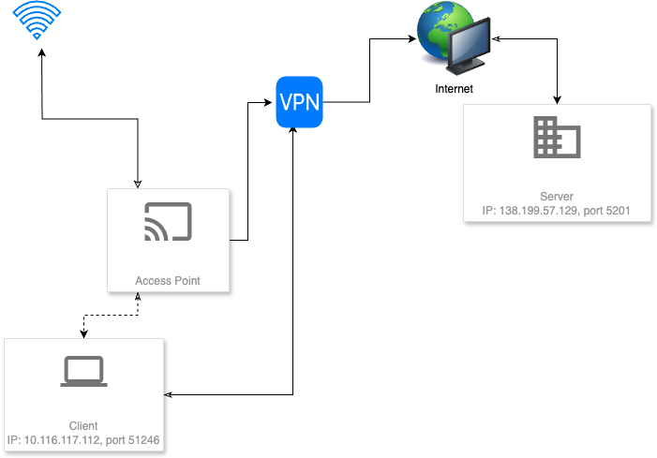
Fig. 2. Client-Server Topology Connected via WiFi with VPN

- Wi-Fi without VPN
The third configuration removed the VPN tunnel while keeping the same Wi-Fi environment. This allows for a comparison to isolate the impact of VPN usage on network performance, showing the native behavior of the Wi-Fi network under similar physical conditions. The topology of such an environment is shown in Fig 3.
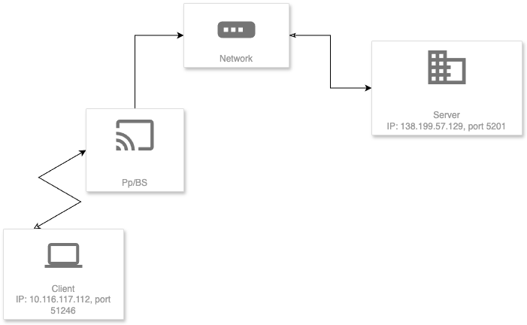
Fig. 3. Client-Server Topology Connected via WiFi without VPN

Each test was conducted during similar times of the day to avoid peak congestion periods, and devices were kept in static positions to ensure environmental consistency across trials.

B. Measurement Tools
The performance measurements were conducted in three different network conditions, each designed to reflect real-world environments commonly encountered by students, professionals, and mobile users. These are outlined as follows:
To evaluate the performance of each network setup, two tools were used: iperf3 for bandwidth and jitter analysis using UDP, and ping for lightweight RTT and packet loss testing using ICMP.
iperf3 is a versatile, open-source tool that enables performance measurement of TCP and UDP networks. In this study, we used iperf3 in UDP mode, which is particularly useful for analyzing jitter and packet loss—two factors that significantly impact streaming and real-time communication.
The following command was used in all scenarios: iperf3 -c 138.199.57.129 -u.
- The -c flag initiates client mode and connects to the remote iperf3 server at IP address 138.199.57.129.
- The -u flag specifies the use of UDP rather than TCP, which is necessary for measuring jitter and packet loss.
iperf3 reports the bitrate (in Mbps), jitter (in ms), and packet loss (%) as part of its standard output. Since UDP does not guarantee delivery or order, it is ideal for simulating streaming traffic and exposing real-time performance issues that TCP-based tools may mask.
ping is a foundational network diagnostic tool that sends ICMP echo request packets to a target IP address and measures how long it takes to receive a response. It is used here to assess:
- Round-Trip Time (RTT): The time (in milliseconds) for a packet to travel to the destination and back.
- Packet Loss: Derived from the number of packets sent versus the number of responses received.
- Jitter (inferred): While not explicitly calculated by ping, jitter can be estimated from the variance in RTT values across multiple samples.
The command used on a Windows 11 machine was: ping 138.199.57.129.
This was executed for multiple intervals (typically 30–60 seconds) to allow sufficient data for statistical analysis. This target IP address was chosen as it consistently responded to both ICMP and UDP requests, ensuring uniformity across tool outputs.
For each network configuration, the following testing procedure was followed to collect consistent and reliable performance data:
- Initialize the environment: Ensure the system is connected to the correct network and that all background processes are minimized.
- Run ping: Execute the ping command and log the RTT and packet loss statistics. Capture a minimum of 20–30 samples per run.
- Run iperf3: Execute the iperf3 command in UDP mode for 10–20 seconds to measure bitrate, jitter, and packet loss. Ensure the server IP and port are reachable.
- Repeat: Conduct three iterations of each test to ensure accuracy and account for transient fluctuations. Average results are used for reporting.
- Record environment variables: Document Wi-Fi signal strength, device battery levels, and VPN status (if applicable) to account for external influences.
The results from all measurements were compiled and organized into tables and graphs for analysis. This structured approach ensures fair comparison between tools and between connection types, and provides a solid foundation for interpreting the differences observed in the performance data.

III. Results
This section presents the empirical results obtained from network performance measurements under three distinct connection scenarios: (1) high-speed wired Ethernet on a university campus, (2) wireless Wi-Fi with an active VPN, and (3) wireless Wi-Fi without VPN. The results include four key metrics: bitrate, packet loss, jitter, and round-trip time (RTT).
These were derived using iperf3 in UDP mode and ping over ICMP, based on the methodology described in Section II. Each experiment was repeated three times per scenario, and the final results reflect the averaged values of each metric. The consistency across runs helped minimize noise from transient network behaviors.
The results of the measurements across the three network environments—Wi-Fi only, Wi-Fi with VPN, and Ethernet only—highlight several notable trends in network performance. Packet loss remained at 0% in all scenarios, both for iperf3 and ping, indicating highly stable connections without any observable data loss during the tests. This suggests that under the test conditions, none of the setups experienced significant congestion or interference.
Jitter, a measure of variability in packet delay, varied more noticeably between the connection types and tools. The Ethernet-only setup demonstrated the lowest jitter in iperf3 at 0.078 ms, confirming the inherent stability and consistency of a wired connection. Wi-Fi with VPN followed closely with 0.378 ms, while Wi-Fi only exhibited slightly higher jitter at 0.395 ms. Interestingly, jitter values from the ping tool were less consistent. While Ethernet showed the highest jitter in ping at 0.5063 ms, this may be an artifact related to how ICMP packets are handled by the operating system or network stack rather than a reflection of poor performance. Notably, Wi-Fi only produced an unusual negative jitter value (-0.0186 ms), which likely reflects a rounding or timing anomaly rather than meaningful data.
Bitrate, as measured by iperf3, was virtually identical across all configurations, with Wi-Fi only and Wi-Fi with VPN both at 1.04 Mbit/s, and Ethernet at 1.05 Mbit/s. The lack of variation suggests that iperf3’s default UDP test parameters, including the capped bandwidth (typically set at 1 Mbit/s unless specified), may have limited throughput regardless of connection quality. This uniformity does not necessarily reflect the full capacity of each network but rather the limits of the test configuration.
Round-trip time (RTT), measured using ping, showed more definitive differences. The Ethernet connection delivered the lowest RTT at 40.356 ms, followed by Wi-Fi only at 41.720 ms. The addition of a VPN resulted in the highest RTT at 42.884 ms, which aligns with expectations due to encryption overhead and added routing complexity introduced by the VPN tunnel. However, the overall RTT differences between the configurations were relatively small, suggesting that under low load conditions, VPN-related delays are modest.
To cross-verify the measurements obtained using iperf3 and ping, each metric was evaluated across all three network conditions: Wi-Fi only, Wi-Fi with VPN, and Ethernet only. Starting with packet loss, both tools consistently reported 0% across all scenarios, validating the reliability and stability of the test environment and confirming that no significant packet drops occurred during transmission. However, jitter—which represents variations in packet delay—showed more nuanced behavior. iperf3 reported the lowest jitter for the Ethernet connection at 0.078 ms, followed by Wi-Fi with VPN at 0.378 ms, and Wi-Fi only at 0.395 ms. This aligns with expectations, as wired connections generally offer more consistent transmission times due to the absence of radio interference and signal fluctuation. Interestingly, the ping jitter values did not entirely match this trend: Ethernet exhibited the highest jitter at 0.5063 ms, while Wi-Fi with VPN showed a significantly lower value at 0.1956 ms. This discrepancy may stem from how ping (which uses ICMP) interacts with network stack processing or scheduling differences in wireless versus wired interfaces, and highlights that different tools can emphasize different aspects of jitter behavior.
Bitrate, measured solely with iperf3, showed very little variation across all three conditions—Wi-Fi only and Wi-Fi with VPN both reported 1.04 Mbit/s, while Ethernet showed a marginally higher rate of 1.05 Mbit/s. This uniformity suggests that the bandwidth during the tests was capped by the iperf3 UDP default configuration rather than actual network capacity, thereby limiting the ability to distinguish throughput differences. Nevertheless, even within this constrained test, Ethernet slightly outperformed the wireless setups, consistent with expectations. The average round-trip time (RTT) obtained from ping followed a clear and interpretable trend. Ethernet provided the lowest RTT at 40.356 ms, followed by Wi-Fi only at 41.720 ms, and Wi-Fi with VPN at 42.884 ms. This increasing latency is logical: wired connections have more direct routing and lower latency; Wi-Fi introduces signal variability and shared bandwidth; and VPN adds further delay due to encryption overhead and additional routing hops.
The comparisons highlight that Ethernet is superior in terms of latency and jitter consistency, especially when cross-verified using iperf3. Wi-Fi connections are more susceptible to environmental variability, while VPN usage introduces predictable additional delay and slight jitter improvement, likely due to its encapsulation and buffering mechanisms. These findings underscore the value of using both iperf3 and ping together—each offers complementary insights into the network performance landscape.
Overall, the Ethernet connection offered the best performance in terms of jitter and latency, while both Wi-Fi scenarios introduced minor but consistent performance penalties. The VPN configuration, though slightly more secure, introduced additional latency and complexity. While bitrate remained constant due to test limitations, the measurements clearly demonstrate the advantages of wired networking and the subtle trade-offs involved when using wireless and VPN-based setups.
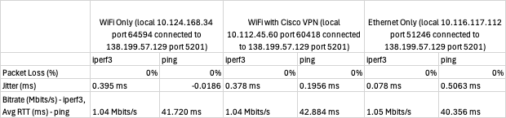
Table. 1. This is a chart showing all the results.
V. Conclusion
This project examined network performance under three different connectivity scenarios—Wi-Fi only, Wi-Fi with VPN, and Ethernet only—by employing iperf3 and ping as measurement tools. Key performance metrics including packet loss, jitter, bitrate, and round-trip time (RTT) were analyzed to assess the quality and consistency of each connection type. The results demonstrated that Ethernet provided the most stable and consistent performance overall, showing the lowest jitter and RTT values, even though the bitrate remained virtually the same across all scenarios due to limitations in the test configuration.
The wireless connections, while free from packet loss, exhibited higher jitter and latency, as expected due to potential interference and signal variability. The addition of a VPN introduced slight overhead, increasing RTT modestly and slightly altering jitter behavior, though without significant degradation in throughput. These findings align with theoretical expectations: wired networks tend to offer more predictable and efficient transmission, while wireless and tunneled connections introduce overhead and variability.
By using both iperf3 and ping, this study highlighted the complementary nature of different network tools. While iperf3 effectively captured UDP-specific metrics such as jitter and throughput, ping provided a straightforward view of latency behavior using ICMP. Together, these tools enabled a more complete picture of end-to-end network performance. Future work could involve testing under higher network loads or varying the iperf3 bandwidth cap to better explore throughput differences across connection types.

